**Kubernetes**

1. **Create a simple pod.yml and create a pod use the ngnix image**
2. Create Pod.yml

The pod.yml file is used in Kubernetes environments for defining and deploying Pods to a Kubernetes cluster.

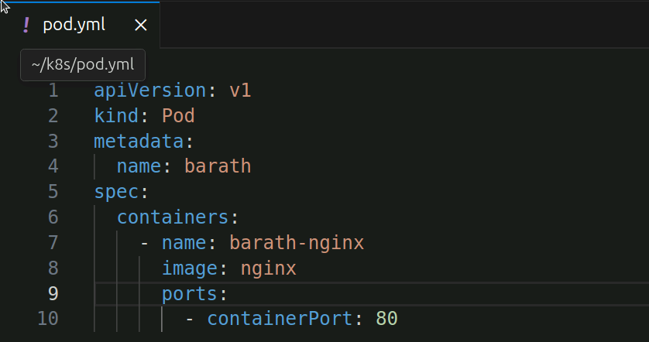

1. kubectl apply -f pod.yml

This will create a Pod based on the configuration provided in the pod.yml file. Here -f means file.



C) Check whether the pod is created or not using kubectl get pods command.

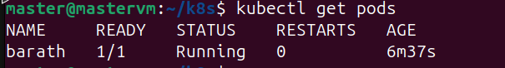

D) Now port forward the pod to access that application

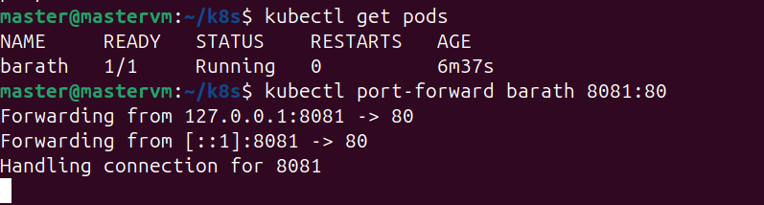

E) Delete the pod

